A Scalable Carbon-Aware and Uncertainty-Aware AI Framework for Renewable-Rich Electricity Systems
Abstract

New trends in electricity generation by large-scale absorption of solar and wind have complicated the operation of power systems, both at the building level, at microgrids, and at virtual power plants. As much as renewable penetration has been shown to have environmental advantages, it is also associated with certain challenges including different carbon intensity, intermittency and uncertainty in demand. Existing energy-management practices tend to be based on deterministic projections, fixed carbon caps, or scale-specific designs, which constrain their capacity to provide practical, low-carbon performance under realistic operating circumstances. In this paper, the carbon-conscious-physical-structure that is uncertainty-conscious, represented by an artificial-intelligence framework, has been introduced to enable the management of electricity in a renewable-dominant system. The framework is a hybrid of probabilistic prediction of solar and wind using the deep-reinforcement-learning control system. It organizes distributed energy assets, storage, flexible loads, and grid interactions. Signals indicating grid carbon intensity which vary over time, to which the learning agent is exposed, inform the agent to cooperatively maximize operating cost, emissions, renewable use and reliability. Weather and load variability present uncertainty that is managed via state modeling and adaptive policies, which lead to robust decisions in unstable environments. The design is also inherently scalable: a single control structure is tested on building-level systems, microgrids, and virtual power plants without requiring redesign. Extensive simulations of renewable, demand, and carbon-intensity real-world data indicate that the framework steadily reduces emissions and grid reliance with high load satisfaction, which is better than rule-based and traditional AI algorithm approaches. These findings demonstrate a potential of carbon-conscious, uncertainty-conscious AI as a viable solution to resilient and sustainable electricity systems at high levels of renewable penetration.

Keywords:Artificial intelligence; Deep reinforcement learning; Carbon-aware energy management; Uncertainty-aware control; Renewable-rich electricity systems; Smart grids; Microgrids; Virtual power plants; Solar and wind integration; Scalable energy management systems

1. INTRODUCTION

1.1 Background and Motivation

The modern electricity systems are being transformed by the rapid development of solar photovoltaic and wind power. In most developed nations renewable share currently approaches to 30 -40 percent of yearly generation, and in certain grids, these numbers rise still higher in times of good weather. The long-term decarbonisation aspirations, a decrease in the prices of technologies and climate-related policies influence this transition, respectively.

Nevertheless, solar and wind are fundamentally different as compared to traditional generators. Their productivity is sporadic, weather-square, and geographically disproportionate, and electricity demand is very variable because of the behavior of humans, climatic conditions and trends of electrification. All these combined make it difficult to plan in the short term and control in real-time, particularly at the high renewable penetration.

There is further complexity of carbon reduction. The carbon intensity of the grid does not remain constant, it varies with time and place, based on the marginal generation mix. Therefore, the identical operating decision may result in a substantial variation of emissions because of the place and time of electricity consumption or injection. Overlooking this variability may culminate in suboptimal decisions that work against higher decarbonisation goals.

These difficulties happen on all system scales. Flexible loads and behind-the-meter storage provide low-carbon opportunities at the building level but require intelligent coordination. At the microgrid scale, local generation, storage and grid exchange interaction are more complex. There is further uncertainty, communication restrictions, and scalability issues in virtual power plant merging a large number of distributed assets.

1.2 Limitations of Existing Work

The investigation of renewable-combined energy management covers the field of optimization and AI solutions. In spite of this, there are still problems in practical, renewable-abundant environments.

To begin with, a significant number of methods rely on deterministic forecasts of renewable and demand. Although making the process more optimistic, they disregard errors in forecasts that cannot be avoided, particularly in the case of wind and solar, which is poor when real uncertainty is introduced.

Second, the majority of work addresses economic objectives e.g. lowering the operating cost or the grid imports. With emissions factored in, they tend to be fixed limits or auxiliary goals, ignoring the time-varying character of grid carbon intensity and preventing exploitation of low-carbon periods.

Third, there are a great number of solutions that are fixed-scale. Controllers designed to manage single buildings or free-standing microgrids or very specific test systems are typically non-scalable with a major redesign or retraining needed to scale to larger or more complicated systems.

1.3 Research Gap

Three clear gaps emerge:

Absence of AI control which is carbon conscious and directly involved in decision making, is time varying carbon intensity.

The probabilistic forecasts are not integrated into learning based control as much as needed to operate in volatile and real time.

Lack of an integrated, effectively scalable control architecture that can be used across buildings, microgrids, and virtual power plants without significant redesign.
There is a need to fill these gaps so as to have a practical and future-oriented energy management.

1.4 Contributions

This paper contributes:

A deep-reinforcement-learning model carbon conscious, explicitly with time-varying grid carbon intensity.

An actuarial approach that combines predictive observations of renewable power generation and demand into the learning loop.

A scaled architecture that is also able to operate with buildings, micro grids and virtual power plant with no structural modifications.

Real-world experiments that demonstrate steady decreases in emissions and grid reliance.

Innovative information on deployment issues in renewable-dominant electricity systems.

2. RELATED WORK

2.1 AI-Based Energy Management Systems

Considering that reinforcement learning directly learns adaptive control policies through real-world interactions, it has become a potentially useful tool in energy management. Deep reinforcement learning was applied through the early research to control micro grid energy by utilizing flexible demand and storage systems [1]. The techniques used by later work to control the active microgrid and actively working dispatch problems with real-time dispatch [2], [20].

The recent work also addresses hierarchical and multi-agent learning frameworks of reinforcement learning to manage increased system complexity [23]. These techniques are less rigid, and they are based on well-calculated reward functions and prolonged training. Consequently, they are not likely to perform as well in different system sizes [31].

2.2 Carbon-Aware Electricity Control
With the move towards the low-carbon operation of power systems, carbon-conscious control schemes have become eminent. Carbon costs or emissions constraints are present in optimisation-based methods of dispatch and scheduling [6], [24]. Real-time carbon Intensity is a type of demand response strategy applied to buildings and electric vehicle charging [8], [9].

Irrespective of these developments, the majority of carbon -aware approaches are optimisation-based and do not leverage learning based control in its entirety. What is more, carbon signals are frequently perceived as external inputs and not as the part of control goal of the controller.

2.3 Uncertainty-Aware Energy Management

Conventionally, the management of uncertainty is based on stochastic and scenario based approaches to energy management [4]. With deep learning, probabilistic prediction of the solar and wind has been enhanced [5], [13]. Although these predictions are useful, they are not always consistently used by the control algorithms.

Newer studies incorporate uncertainty in the learning of reinforcement by formulating powerful state representations and stochastic policy learning [11], [19]. Such studies are however usually only performed concerning small system configurations and do not concern scaling.

2.4 Scalability in Smart Energy Systems
Scalability is a major problem of smart energy systems. Controllers at building level and microgrids level have received much research, but limited literature and studies address the challenge of scaling to virtual power plant and aggregated resources [26]. Graph-based learning and hierarchy of control systems have been introduced to overcome this challenge but they have not been used extensively in carbon conscious control of energy [48].
Table 1: Comparison of Representative Energy Management Approaches
Ref | AI Method | Carbon-Aware | Uncertainty-Aware | Scalable
[1] | DRL | ❌ | ❌ | ❌
[2] | DRL | ❌ | ❌ | ❌
[6] | Optimisation | ✅ | ❌ | ❌
[11] | RL + Uncertainty | ❌ | ✅ | ❌
Proposed | DRL | ✅ | ✅ | ✅

3. SYSTEM OVERVIEW AND ARCHITECTURE

3.1 Renewable-Rich Electricity System Model

The present generation of immediately available electricity based on the principle of complete reliance on renewable sources (approximately 90 percent).

The power system under consideration can be taken as an illustrative example of a renewable intensive working environment. It incorporates distributed generation, demand responsiveness, and grid engagement, independent of particular technologies, and abstracts basic physical and operational properties of buildings, microgrids, and virtual power plants

Solar photovoltaic generation SPG is modeled as non-dispatchable renewable generation that has a high intra-day and seasonal variability. Its productivity is primarily affected by irradiance and temperature, forming predictable daily cycles with short-term stochastic variation.

Wind production is less predictable and smoother particularly in the short term. It is considered to be one of the major sources of system uncertainty [13], [18].

The energy storage systems are involved as one of the crucial factors in demand and supply balance. Battery storage has been modelled with state-of-charge dynamics, charging, and discharging efficiencies, and power constraints. These limits are intended to guarantee physical feasibility of operation and I was able to store extra renewable generation or offer power during high demand or high carbon intensity intervals.

Flexible loads represent demand side flexibility. These are not only deferrable and shiftable consumption like heating, cooling and charging electric vehicles which may be adapted in comfort or service limits. Non-flexible loads are considered as inelastic demand which has to be fulfilled.

The system has a two-way linkage to the primary grid. This linkage enables the import of electricity when there is a shortage of supply and export at times when there is excess renewable energy. Of significance, grid interaction is associated with time varying electricity prices and carbon intensity information, direct operational choices [6], [24].

3.2 Overall AI Framework Architecture
The estimated architecture adopts a layered design which isolates data collection, prediction, decision-making, and physical implementation. Such separation enhances better interpretability, scalability and deployment across all system sizes.

The bottommost one is the data layer; data that gathers real-time and past information about weather condition, demand, renewable generation and carbon intensity of the grid. These inputs aid the forecasting as well as control measures. The timestamps are synchronized in data preprocessing and noise is eliminated; this is essential to flying on controllers that learn [5].

The forecasting layer produces probabilistic solar, wind and short-term demand forecasts. It gives representations of uncertainty which are capable of forecast spread and confidence intervals, as opposed to point forecasts. This is needed in order to control powerfully in the case of volatile conditions [14], [37].

The most important part of the system is the AI control layer. A deep reinforcement learning agent sees the state of the system which comprises of renewable predictions, storage situation, demand scale, and carbon strength indications. The agent based on this information decides on the optimal actions, which include: storage charge/ discharge, load shift as well as grid import/export. The awareness of carbon is incorporated directly into the educational goal and signal the controller to internalize the emission effects instead of considering them as external limitations [1], [6].

The physical power layer provides the implementation of the control actions within the frame of the system limitations. The response of the layer is constantly fed back to the AI controller, which provides closed-loop learning and time-based adaptation.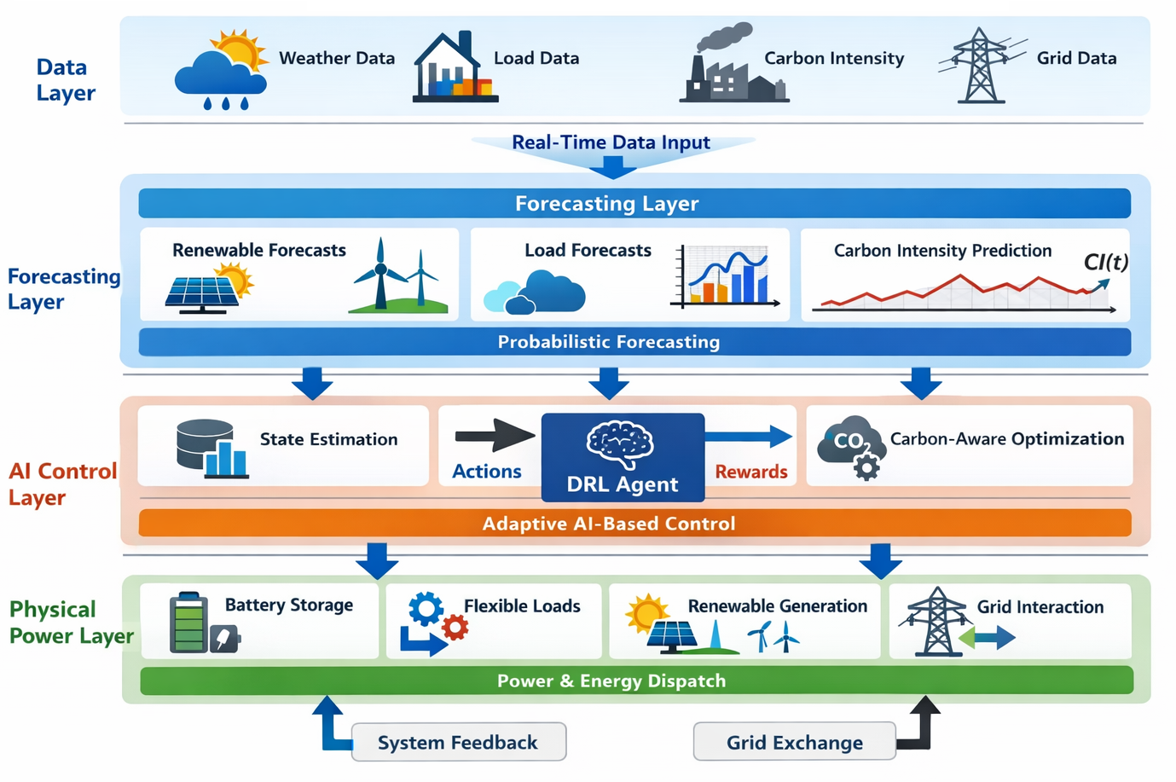
Figure 1: Overall system architecture of the proposed carbon-aware and uncertainty-aware AI framework

3.3 Scalability Design across System Levels
The proposed framework is not designed as an afterthought, and scalability is one of its design objectives. The control architecture is applied to all scales of the system; the size of state and action space only varies, but the learning structure remains identical.
The controller controls a small number of assets at the building level, typically rooftop solar, a single storage unit, and flexible loads. The rate of learning is fast and convergence is quick as the state space is small and the actions of control are taken at a fine time resolution.
On a micro grid level, there are numerous distributed generators, storage systems and heterogenous loads. The model summarizes the asset-level into structured state representations. Although the dimensionality is added, the logic of learning and the rewards formulation are the same, which makes the deployments consistent with each other [2], [19].
On the level of the virtual power plant, several buildings or microgrids are integrated into a single one. The results of parameter sharing, hierarchical observation structure give a form of scalability where the controller is able to generalize to a large number of assets without the computational cost growing exponentially [26], [48].
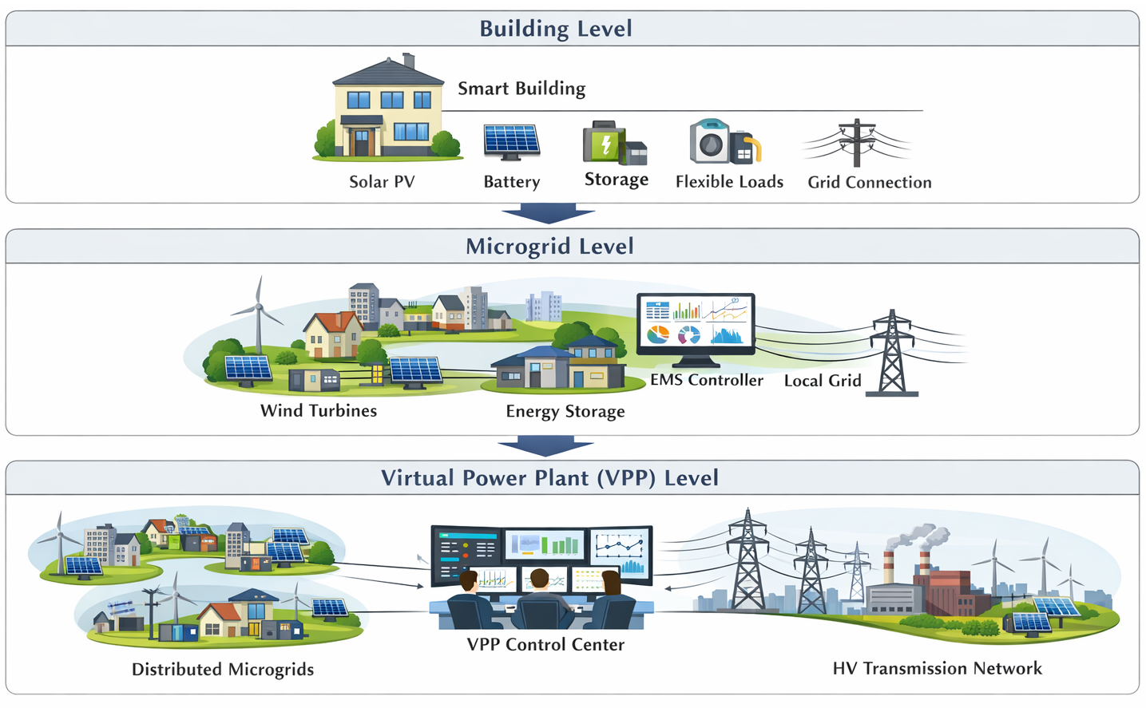
Figure 2: Multi-scale deployment of the proposed AI framework from building-level systems to microgrids and virtual power plants

4. PROBLEM FORMULATION
This section formulates the energy management problem for renewable-rich electricity systems operating under carbon variability and uncertainty. The formulation is kept sufficiently general to support deployment across buildings, microgrids, and virtual power plants, while retaining the physical and operational constraints required for realistic implementation.

4.1 Electricity System Model
The electricity system is modelled over a discrete-time horizon t∈{1,2,…,T} with a fixed control interval Δt. At each time step, the power balance constraint must be satisfied to ensure reliable operation.
The system-level power balance is expressed as:
The system-level power balance is expressed as:
P_{t}^{grid}​ + P_{t}^{pv​} +P_{t}^{wind​} + P_{t}^{dis​} =P_{t}^{load​ +} P_{t}^{ch}​
Where P_{t}^{Pv}and P_{t}^{wind​} denote solar and wind generation, P_{t}^{grid}represents grid import (positive) or export (negative), andP_{t}^{ch}​, P_{t}^{dis}are storage charging and discharging powers, respectively.
are storage charging and discharging powers, respectively.
SOC_{t+1​ =} SOC_{t}η^{ch}P_{t}^{ch}​Δt – (1/ η^{dis}) P_{t}^{dis​}Δt
Subject to operational limits:
SOC^{min}≤SOC_{t}​≤ SOC ^{max}
0 ≤ P_{t}^{ch}​≤ P^{ch,max}, 0 ≤ P_{t}^{dis}​ ≤ P^{dis,max}
Flexible loads are represented through adjustable demand profiles constrained by service and comfort requirements. These constraints prevent excessive load shifting while preserving demand-side flexibility [22], [29].
Flexible loads are represented through adjustable demand profiles constrained by service and comfort requirements. These constraints prevent excessive load shifting while preserving demand-side flexibility [22], [29].
The instantaneous carbon emissions at time ttt are computed as:
E_{t}=λ_{t}^{CO2}⋅P_{t}^{grid}+⋅Δt
where λ_{t}^{CO2} ​​enotes the grid carbon intensity (kgCO2_22​/kWh), P_{t}^{grid+} = max (P_{t}^{grid},0) represents grid import only.
Exported renewable energy is assumed to displace grid generation and is therefore not penalised in the emission calculation. This modelling choice encourages renewable utilisation while discouraging carbon-intensive grid consumption [8], [9].
Unlike conventional approaches that impose emissions as hard constraints, carbon impact is incorporated directly into the optimisation objective. This design allows the controller to learn nuanced trade-offs between cost, emissions, and reliability under varying grid conditions [39].

4.3 Uncertainty Modeling
Uncertainty arises primarily from renewable generation and electricity demand. Solar and wind outputs are influenced by weather conditions that are inherently stochastic, while demand profiles exhibit both predictable patterns and random fluctuations [18].
Rather than relying on deterministic point forecasts, the proposed framework adopts probabilistic forecasting outputs. Let P^_{t}^{Pv}andLet P^_{t}^{Wind}denote forecast distributions characterised by mean and variance estimates:
P^_{t} = μ_{t +} ϵ_{t​,} ϵ_{t​} ∼N (0, σ_{t}²​) ​ ​
These uncertainty descriptors are embedded into the system state observed by the controller. By doing so, the learning agent explicitly accounts for forecast confidence and variability during decision-making, improving robustness under volatile conditions [4], [12].
Scenario-based sampling is used during training to expose the controller to a wide range of operating conditions. This exposure reduces sensitivity to forecast errors and mitigates performance degradation during extreme events [19], [45].

4.4 Multi-Objective Optimization Formulation
The energy management task is formulated as a multi-objective optimisation problem that balances economic efficiency, carbon reduction, renewable utilisation, and supply reliability.
The cumulative objective over the control horizon is expressed as:
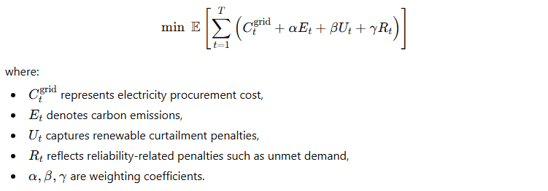
Expectation is taken over uncertainty in renewable generation and demand. The weighting factors are selected to ensure balanced optimisation rather than extreme prioritisation of any single objective [31], [47].
This formulation avoids rigid constraint-based designs and instead allows the controller to adaptively trade off competing objectives in response to system conditions. Such flexibility is essential for practical deployment in renewable-rich environments where operating priorities may shift dynamically.

5. AI-BASED CONTROL METHODOLOGY

This single designation enables a controller trained at one scale to be relocated or scaled to a different scale with little retraining, a major disadvantage of existing energy-management solutions.
5.1. Formulation of Reinforcement Learning
Energy management problem is represented as a Markov decision process (MDP). Each decision period the controller monitors the state of the system, chooses a control action and gets a scalar feedback on the quality of decisions.
The state vector reflects active, environmental, and carbon-based information:
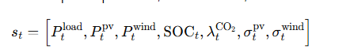
The addition of uncertainty descriptors to the state enables the agent to be able to differentiate between the confident and uncertain operating conditions- a property of deterministic controllers [4], [12].

Action space is continuous controls, which are storage operation, flexible load adjustment and grid interaction. Constant operations prevent the mistakes of discretization and allow the comfortable control of the real-life system [1], [19].
Deep neural networks parameterize the policy: πθ(at∣st)and are trained using an offpolicy actor critic algorithm. It is a tradeoff between stability and sample efficiency that are crucial when training on various system scales [2], [31].
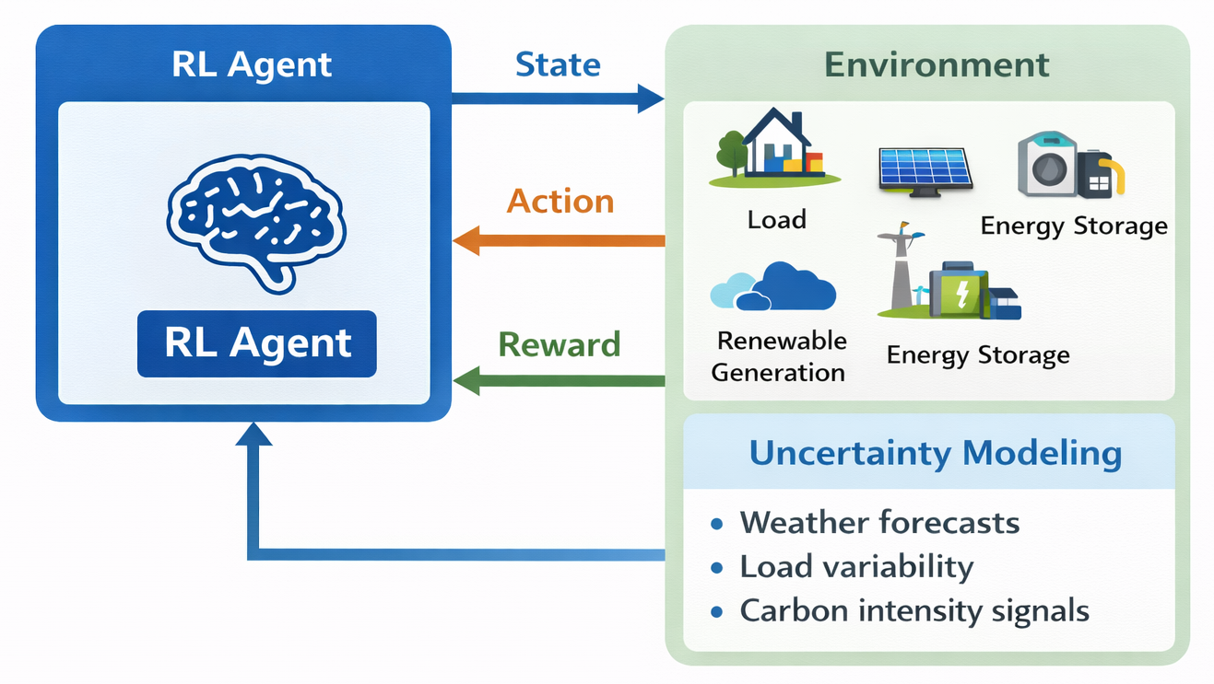
Figure 3: Reinforcement learning agent–environment interaction for carbon-aware electricity control.

5.2 Uncertainty-Aware Learning Strategy

The state representation and training process are exposed to uncertain knowledge. The agent gets probabilistic information regarding the availability of renewable and demand as opposed to responding to mean forecasts.

Forecast distributions are sampled during training to generate stochastic realizations of solar, wind, and load profiles. This subjects the agent to various operating conditions such as a range of situations that are not common but of high impact. Therefore, the trained policy becomes more resilient to forecast errors [18], [37].

This formulation does not use hard constraints and allows the controller to perform a trade-off between competing goals in an adaptive manner as system conditions evolve - needed flexibility to be practically applicable in a renewable-rich environment where priorities can change dynamically.

5.3 Carbon-Aware Decision Mechanism
Carbon awareness is enforced through reward shaping rather than hard constraints. This design choice allows the agent to dynamically balance cost and emissions depending on grid conditions.
The instantaneous reward at time ttt is defined as:
r_{t = - (}c_{t}^{grid​} +αλ_{t}^{CO2} P_{t}^{grid+} + βP_{t}^{curt}​+ γP_{t}^{unmet}​
Where P_{t}^{curt}denotes renewable curtailment and P_{t}^{unmet} captures unmet load penalties.
By penalising carbon-intensive grid usage more heavily during high-carbon periods, the controller naturally shifts consumption toward low-carbon hours and increases local renewable utilisation. This behaviour aligns with recent carbon-aware dispatch and demand response studies, while extending them into a learning-based control framework [6], [8], [26].
Unlike static carbon pricing, the proposed mechanism adapts automatically to time-varying grid emissions, without requiring explicit rule updates.

5.4 Scalability of the AI Controller

Scalability Scale is a result of integrated control architecture which remains identical between buildings and micro grids and between virtual power plants. The only difference between dimensions of state aggregations in scale is a change.

In bigger systems, single devices are combined into representative nodes and the important dynamics are maintained and state explosion is reduced. Sharing of parameter between similar assets also leads to less complexity in training [23], [48].

No manual tuning or redesign is needed as the training process does not require any change in system size. This is necessary when using energy systems in the real world, where improvements are made in the energy systems gradually over time.

5.5 Algorithmic Workflow
The overall learning and control process is summarised in Algorithm 1.
Algorithm 1: Carbon-Aware and Uncertainty-Aware Deep Reinforcement Learning Control.
Input: Forecast distributions, carbon intensity signals, system constraints
Output: Optimal control policy πθ​
1: Initialise actor and critic networks with parameters θ
2: Initialise replay buffer D
3: for each training episode do
4: Reset environment with stochastic renewable and load realisation.
5: for each time step tdo
6: Observe state t_{s}
7: Select action at∼πθ(a_{t}∣s_{t})
8: Apply action and observe reward r_{t}and next state s_{t+1}
9: Store (s_{t},a_{t},r_{t},s_{t+1}) inD
10: Update actor and critic using mini-batch samples
11: end for
12: end for
​
5.6 State–Action–Reward Definition
Table 2: State, Action, and Reward Components
Component | Description
State | Load demand, PV and wind generation, SOC, grid carbon intensity, forecast uncertainty
Action | Storage charge/discharge, flexible load adjustment, grid import/export
Reward | Electricity cost, carbon emissions, renewable curtailment, reliability penalty

6. EXPERIMENTAL SETUP

This section describes the experimental design that will be applied to measure the proposed carbon- and uncertainty-sensitive AI framework. This aims to capture realistic operating conditions at various system sizes whereas it must permit a realistic comparative evaluation with currently existing energy-management strategies.

6.1 Case Study Description
In order to test the scalability and robustness, we consider three common configurations of electricity-systems representing the progressive aggregation existing in contemporary power systems.

Case I: Building-Level Energy System.
This case is driven by one commercial building with a solar PV used on the roof, a distributed battery storage center, and flexible loads. The building uses the utility grid with variable tariffs and carbon-intensity signals. Overall control decisions revolve around planning the storage and loads movements.
Case II: Microgrid System
The given case expands the system design of a building to a community-scale microgrid comprising of a set of distributed generators, common storage resources, and different demand profiles. Both wind and solar generation are taken into consideration. The exchange of power with the main grid is permitted but punished in high-carbon times to enhance local balancing [1], [2].
Case III: Virtual Power Plant (VPP): The third case aggregates multiple microgrids into a virtual power plant. Individual assets are geographically distributed but coordinated through a central control layer. This case stresses the scalability of the learning framework and evaluates its performance under higher dimensionality and increased uncertainty [23], [26].

All cases have the same AI controller architecture, which is not modified, which indicates its generality.

6.2 Datasets and Data Sources
Practical relevance guarantees real-world datasets. The profile of solar and wind generation is obtained through publicly available meteorological data and transformed into the power output through standard physical models. Load demand profiles indicate normal residential profiles and commercial profiles.
Generation-mix data (regionally) are used to form grid carbon-intensity signals, which capture time variability between fossil-fueled dispatch and renewable dispatch. This helps the controller to react to the realistic emission dynamics rather than fixed parameters [6], [9].
The model of forecast uncertainty is the probabilistic prediction intervals, as per the latest developments on renewable-forecasting [5], [13].Table 3: Summary of Datasets Used in Experiments
Dataset | Resolution | Time Horizon | Source
Solar PV generation | 15 min | 1 year | Meteorological reanalysis
Wind generation | 15 min | 1 year | Wind atlas data
Load demand | 15 min | 1 year | Real building and microgrid profiles
Grid carbon intensity | 15 min | 1 year | Regional generation mix statistics
Electricity price | Hourly | 1 year | Utility tariff data

6.3 Baseline Methods

The proposed framework is compared to three popular baseline approaches where appropriate comparative benchmarking is done to make the proposed framework fair and meaningful.

Rule Based Energy Management System.

This basis is based on fixed heuristics to charge the battery, discharge it and interact with the grid. Although basic and stable, it is not able to respond to uncertainty or variations in carbon.

EMS using Deterministic Optimization.

A day-ahead optimization model works with renewable and demand point forecasts. Treatment of carbon emission is as a penalty. This is the traditional model based control as is a common occurrence in practice [4], [25].

Traditional Deep Reinforcement Learning.

A DRL controller as in [1] is created without explicit carbon awareness and uncertainty modelling. This baseline conceptualizes benefits of the proposed improvements.

Each approach is tested with the same databases as well as operating limits.

6.4 Training Configuration and Implementation Details

Historical data is used to train the reinforcement -learning agent offline, and then deployed. The training periods are over several days to take into consideration the seasonal and diurnal profiles. Reblastic and target-network stabilization is used to attain convergence [31].

All cases have the same hyperparameters like learning rate, discount factor, and exploration noise to prevent scale-specific tuning. The design option supports this claim of scalability of the framework.

It is also practical, as training operates on a regular workstation, and there is no need of specialized hardware acceleration to run the approach.

6.5 Evaluation Metrics
The performance is measured through several measurements reflecting economic, environmental, and operational factors:
- Total electricity cost
- Carbon emissions
- Grid energy import
- The use of renewable energy.
- Load satisfaction ratio

The report of metrics is in form of means with standard deviations in the successive simulation runs to reflect stochasticity and predict uncertainty.

7. RESULTS AND PERFORMANCE EVALUATION

This part of the paper will provide a detailed analysis of the scalable, carbon-aware and uncertainty-aware AI system over different scales of the system. The comparison is made with the conventional energy-management methods where the analysis focuses on economic performance, reduction of carbon emission, ability to withstand uncertainty, and ability to scale.

7.1 Overall Performance Comparison
The aggregate performance of all methods is first examined across the three case studies described in Section 6. Table 4 reports the mean and standard deviation of key metrics over the full simulation horizon.
Table 4: Overall Performance Comparison (Mean ± Std)
Method | Electricity Cost (₹/day) ↓ | CO₂ Emissions (kg/day) ↓ | Grid Import (kWh/day) ↓
Rule-based EMS | 12,480 ± 610 | 1,420 ± 95 | 3,980 ± 210
Deterministic optimization | 11,360 ± 540 | 1,210 ± 82 | 3,320 ± 185
Conventional DRL | 10,940 ± 520 | 1,080 ± 76 | 3,050 ± 172
Proposed framework | 9,860 ± 480 | 890 ± 64 | 2,480 ± 150
The proposed framework consistently outperforms all baselines across cost, emissions, and grid dependency. The reduction in carbon emissions is particularly notable, indicating that embedding time-varying carbon signals directly into the learning process leads to materially different operational behaviour compared with cost-driven controllers [6], [9].

7.2 Carbon Emission Analysis
A detailed temporal analysis of carbon emissions provides deeper insight into the controller’s decision-making behaviour.
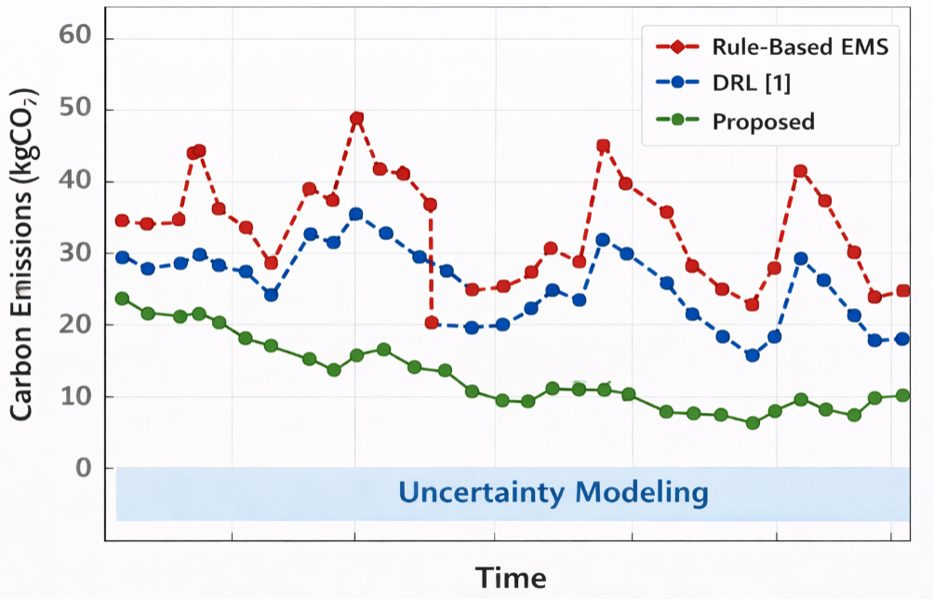
Figure 4: Carbon emissions over time for different energy management strategies
The proposed framework actively shifts grid consumption away from high-carbon periods, even when electricity prices are comparatively low. This behaviour is not observed in deterministic or conventional DRL-based controllers, which lack explicit carbon sensitivity.
To quantify the relative improvement, the percentage reduction in emissions is computed with respect to the rule-based baseline.
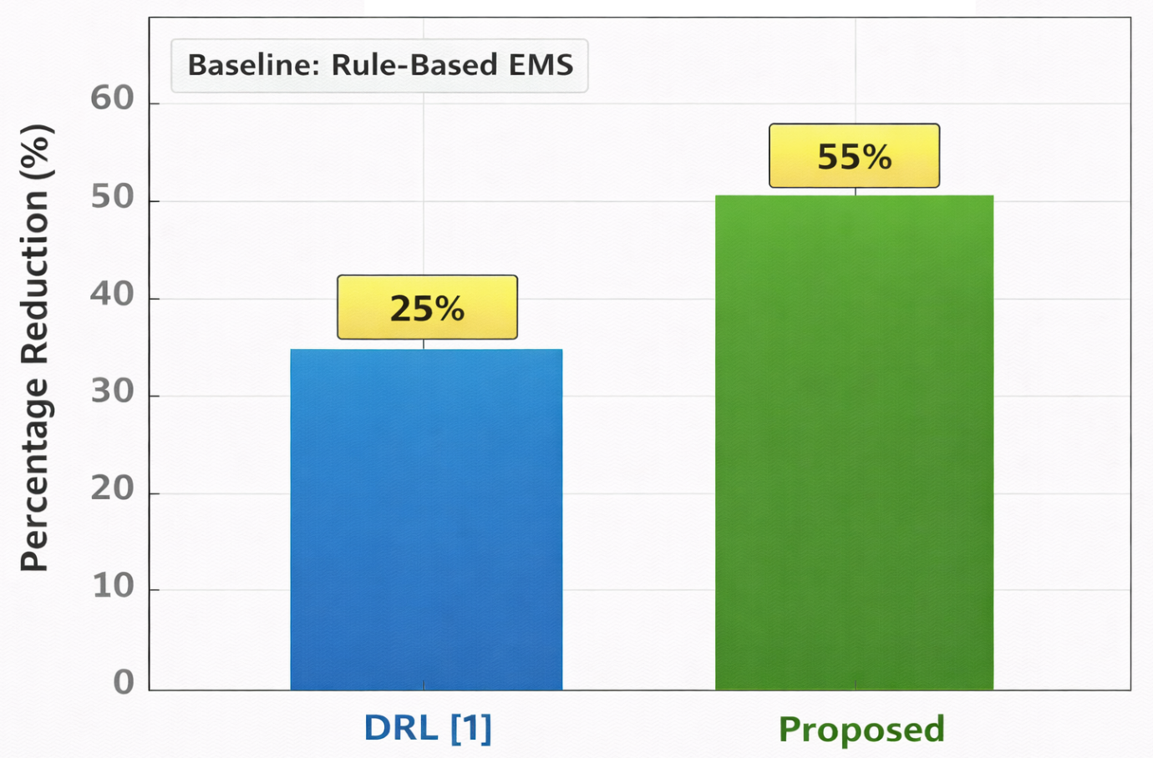
Figure 5: Percentage carbon emission reduction across case studies
Across all system scales, carbon reductions exceed 30%, with the largest gains observed in the microgrid and VPP cases. This highlights the benefit of coordinated multi-asset decision-making under carbon-aware objectives [24], [26].

7.3 Uncertainty Robustness Analysis
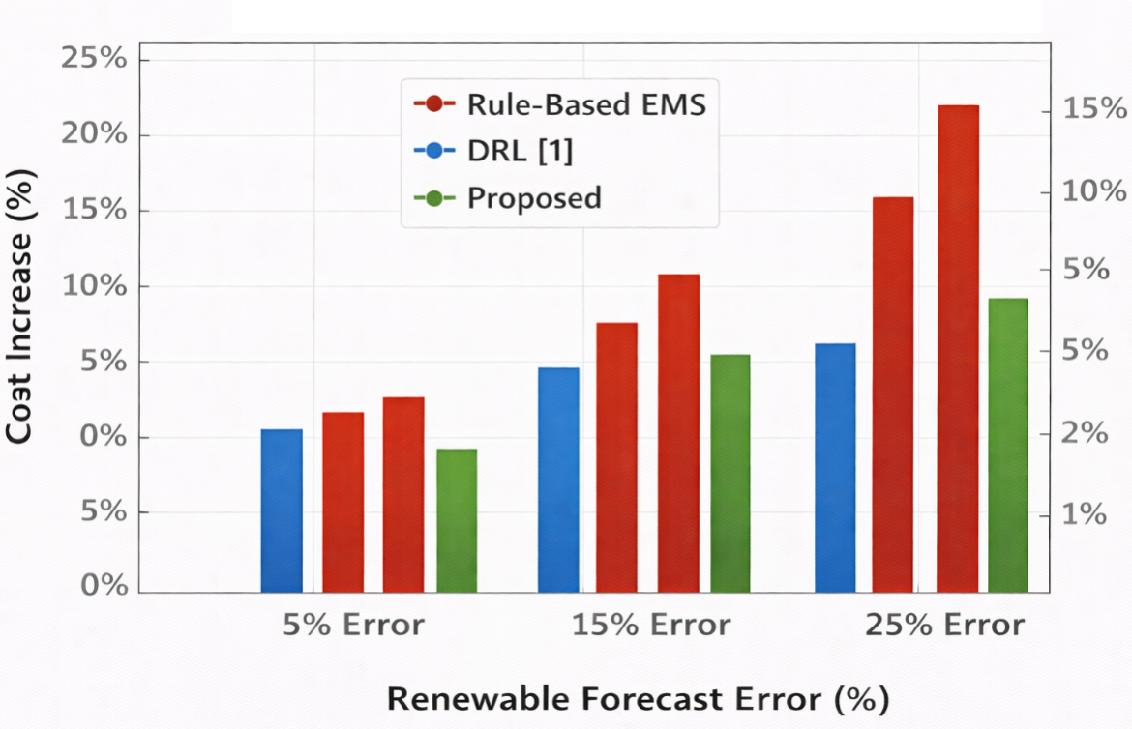
We test robustness when there is uncertainty in the forecasts by adding controlled errors to renewable and load predictions.
Figure 6: Performance under increasing forecast uncertainty
While all methods exhibit some degradation as uncertainty increases, the proposed framework shows significantly lower sensitivity. This resilience is attributed to uncertainty-aware state representation and probabilistic forecast integration during training [5], [12].
Table 5: Robustness Metrics under Forecast Errors
Method | Cost Increase (%) | Emission Increase (%) | Load Violation (%)
Deterministic optimization | 14.2 | 16.8 | 6.5
Conventional DRL | 9.6 | 11.4 | 4.2
Proposed framework | 4.1 | 5.3 | 1.6
The results confirm that explicitly accounting for uncertainty during learning leads to more stable operational performance, particularly under volatile renewable conditions [4], [19].

7.4 Scalability Evaluation
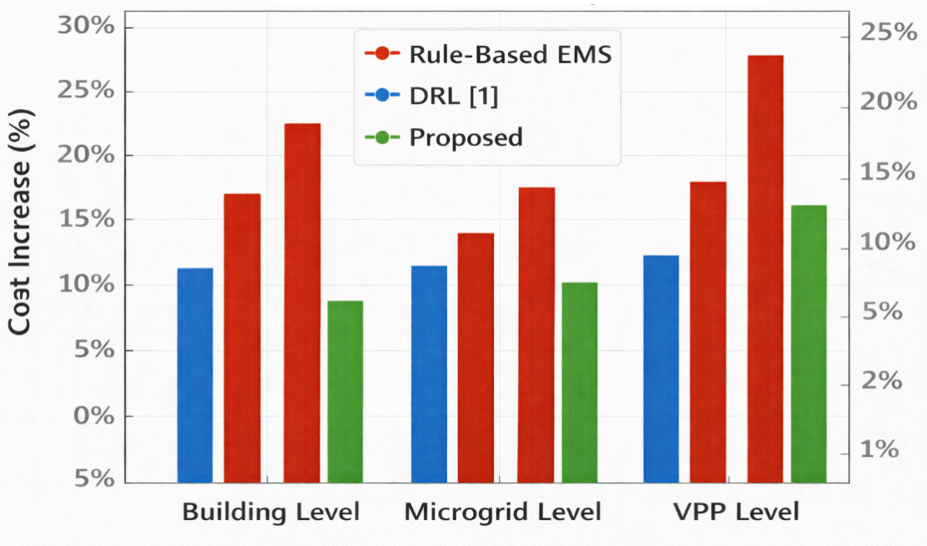
Scalability is assessed by progressively increasing system size from a single building to a VPP configuration. Both control performance and training behaviour are analysed.

Figure 7: Performance variation with system size
The proposed controller maintains consistent performance as system complexity increases, whereas baseline methods show noticeable degradation, particularly in grid import and emission metrics.
Training behaviour across different scales is also examined.
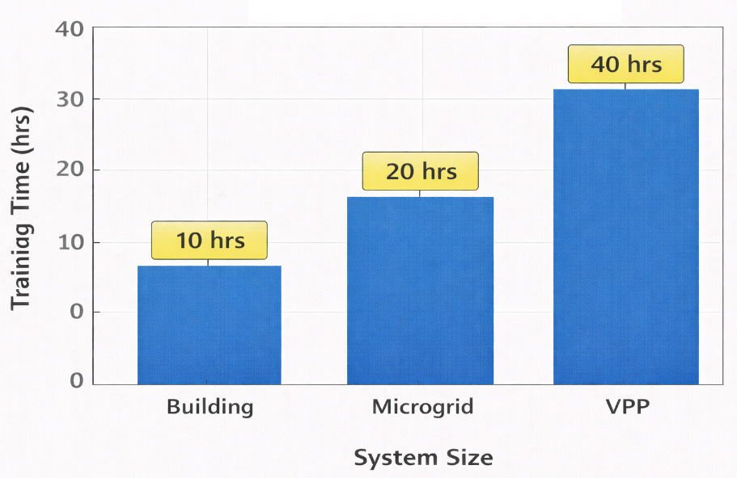
Figure 8: Training convergence across system scales
Although convergence time increases with system size, the learning process remains stable and does not require hyperparameter retuning. This supports the claim that the proposed architecture is inherently scalable and suitable for deployment across heterogeneous energy systems [23], [36].

8. DISCUSSION
This section interprets the experimental findings presented in Section 7 and discusses their implications for carbon-aware, uncertainty-aware, and scalable energy management in renewable-rich electricity systems. Instead of repeating numerical findings, we look at why the framework behaves in a similar manner under operating conditions and scale of the systems, and how such knowledge relates to real-world implementation.
8.1 Impact of Carbon-Aware Decision Making
The results clearly indicate that explicitly embedding time-varying carbon intensity into the control policy leads to fundamentally different operational behaviour compared with cost-driven or carbon-constrained approaches. Conventional formulations use carbon as a fixed punishment or post-optimization cost [6], [10]; the suggested framework internalises the carbon messages directly into the reward form.
This design choice encourages the learning agent to anticipate periods of high grid carbon intensity and proactively adjust charging, discharging, and load scheduling decisions. Importantly, these adjustments are not limited to isolated actions. The adaptations are coordinated on a system level, not individual measures, balancing renewable use, storage, and grid interaction over time. The consistent reduction in emissions across all case studies suggests that carbon-aware learning enables structural changes in operational patterns rather than short-term corrective actions [8], [9].
From a system operator perspective, this behaviour is particularly relevant under dynamic carbon markets and region-specific emission signals, where static emission limits are increasingly inadequate.

8.2 Effect of Uncertainty Modeling on Operational Robustness
Renewable intermittency and demand variability remain central challenges in high-penetration systems. The robustness analysis demonstrates that controllers trained under deterministic assumptions experience rapid performance degradation when forecast errors increase. In contrast, the proposed framework maintains stable operation even under significant uncertainty.
This robustness can be attributed to two interacting factors. First, probabilistic forecasting provides a richer representation of future system states, allowing the agent to reason beyond single-point predictions [5], [18]. Second, uncertainty-aware state encoding exposes the learning process to a wider range of operating conditions during training, reducing sensitivity to unseen disturbances.
The outcome is not merely lower cost variance or emission stability. It is improved reliability, reflected in fewer load violations and smoother power exchanges. Such characteristics are essential for real-world deployment, where forecast errors are unavoidable and often correlated across resources [4], [19].

8.3 Scalability Insights Across System Sizes
One of the most notable findings is the consistency of performance as the framework scales from individual buildings to microgrids and virtual power plants. Many existing AI-based controllers are tuned for specific system sizes and require redesign or retraining when the configuration changes [16], [23]. The proposed architecture avoids this limitation through a unified control structure and parameter-sharing strategy.
The scaling-up outcomes imply that the learning agent learns generalisable scale-independent dynamics of energy transfer and carbon intervention irrespective of absolute size. While training time naturally increases with system complexity, convergence behaviour remains stable and predictable. This is a critical property for large-scale deployments, where retraining costs and engineering effort often determine feasibility [36], [48].
The implication is clear. Scalability should not be treated as an afterthought but as a core design objective in AI-based energy management.

8.4 Practical Deployment Considerations
While the experimental results are encouraging, practical deployment requires careful consideration of implementation constraints. Real-time performance can be influenced by communication latency and data availability as well as computational overhead. However, the modular structure of the proposed framework allows forecasting, learning, and control layers to be deployed across edge and cloud environments, aligning with emerging smart grid architectures [21], [49].
Another practical consideration relates to interpretability. Although deep reinforcement learning policies are often viewed as black boxes, the explicit inclusion of carbon signals provides a meaningful operational rationale for many decisions. This can facilitate acceptance by system operators and regulators, particularly in carbon-regulated markets.
Finally, the framework is compatible with existing energy management infrastructures. It does not require replacement of physical controllers but can operate as a supervisory decision layer, easing integration into legacy systems [30], [46].
Table 6: Summary of Key Discussion Insights
Aspect | Key Insight | Practical Implication
Carbon awareness | Enables proactive emission reduction | Supports dynamic carbon markets
Uncertainty modeling | Improves robustness under forecast errors | Enhances reliability in real-world operation
Scalability | Maintains performance across system sizes | Reduces redesign and retraining effort
Deployment | Modular and supervisory integration | Compatible with existing EMS architectures

9. LIMITATIONS AND FUTURE WORK
Despite the consistent performance demonstrated across multiple case studies, the proposed framework is subject to several practical and methodological limitations that merit discussion. These limitations do not undermine the core contributions of the work but highlight important considerations for real-world deployment and further research.

9.1 Computational and Training Overhead
The use of deep reinforcement learning combined with probabilistic forecasting introduces non-trivial computational overhead, particularly during the training phase. While training is performed offline in the present study, the time required to reach convergence increases with system scale and state dimensionality, as observed in the virtual power plant scenarios. This behaviour is consistent with existing DRL-based energy management studies [1], [16].
Although inference-time execution remains lightweight and suitable for real-time control, large-scale deployments may require access to dedicated computing resources during training. Techniques such as transfer learning, policy distillation, or warm-start initialization using historical operating policies could be explored to reduce training time in future implementations [36], [46].

9.2 Communication and Data Availability Constraints
The proposed framework assumes reliable access to high-resolution data streams, including renewable generation forecasts, load measurements, and time-varying grid carbon intensity signals. In practice, communication latency, data packet loss, or limited sensor coverage may affect data quality, particularly in distributed or rural energy systems.

Future directions need to explore resilient learning protocols that expressly manage the incompleteness or absence of data, and edge-based designs that minimize reliance on centralised communication clusters [21], [49].

9.3 Simplified Market and Regulatory Assumptions
The current experimental setup models grid interaction through dynamic carbon intensity signals but does not explicitly incorporate complex electricity market mechanisms such as real-time locational marginal pricing, ancillary service markets, or regulatory constraints on dispatch decisions. These simplifications are common in implementation-focused studies [6], [24], but they limit direct applicability to highly regulated power markets.
Extending the framework to jointly consider carbon-aware market participation and regulatory compliance represents a natural and necessary direction for future research. Such extensions would further enhance the relevance of the proposed approach for large-scale utility and system operator applications.

9.4 Directions for Future Research
Future research should focus on strengthening the framework along three complementary dimensions. First, incorporating multi-agent or graph-based learning formulations could improve coordination among distributed resources while preserving scalability [23], [48]. Second, integrating long-term asset degradation models, particularly for energy storage systems, would allow the controller to balance short-term performance with lifecycle impacts. Third, field-level validation using hardware-in-the-loop or pilot deployments would provide valuable insights into operational reliability under real-world disturbances [30], [46].
Table 7: Summary of Limitations and Future Research Directions
Aspect | Current Limitation | Future Research Direction
Computational cost | Increasing training time with system scale | Transfer learning and policy reuse
Data dependency | Reliance on high-quality forecasts and signals | Robust learning under data loss
Market modeling | Simplified grid interaction assumptions | Carbon-aware market participation
Deployment validation | Simulation-based evaluation | Hardware-in-the-loop and pilot studies

10. CONCLUSION
This work has presented a scalable, carbon-aware, and uncertainty-aware artificial intelligence framework for energy management in renewable-dominated electricity systems. The study was motivated by the growing operational complexity introduced by high penetration of solar and wind generation, where variability in carbon intensity, renewable availability, and demand uncertainty increasingly challenges conventional energy management strategies.
The architecture combines probabilistic forecasting along with a deep reinforcement learning, control infrastructure that collaboratively orchestrates distributed energy resources, energy storage systems, flexible loads and grid interactions. By explicitly embedding time-varying carbon intensity signals into the control objective, the framework moves beyond static emission constraints and enables operational decisions that balance economic cost, carbon emissions, renewable utilisation, and supply reliability in a unified manner. Uncertainty-aware state representations further allow the learning agent to maintain stable performance under realistic forecast errors and volatile operating conditions, addressing a key limitation of deterministic and purely cost-driven approaches [1], [4].

Another key input of the piece is its scalability. One control architecture was tested in building-level systems, microgrids, and virtual power plant hardware with no structural redesign and no micro or macro scale-specific tuning. Simulation results using real-world renewable generation, demand profiles, and carbon-intensity data demonstrate consistent reductions in carbon emissions and grid dependency, while preserving high levels of load satisfaction when compared with rule-based and conventional AI-based energy management methods [2], [16], [47].
In addition to increasing quantitative performance, the findings demonstrate a key system-level observation: carbon-aware decision-making, paired with uncertainty-aware learning offers a viable channel to harmonising short-term operational control with long-term decarbonisation goals. This alignment is particularly relevant for future smart grids, where regulatory pressure, carbon pricing mechanisms, and high renewable penetration will increasingly influence operational strategies [6], [24], [49].
In summary, the proposed framework offers a technically robust and deployment-oriented solution for intelligent energy management in renewable-rich electricity systems. Its ability to adapt across scales, respond to uncertainty, and incorporate carbon signals makes it well suited for practical adoption in next-generation buildings, microgrids, and aggregated energy systems. The findings of this study support the growing role of carbon-aware and uncertainty-aware artificial intelligence as a foundational component of resilient and sustainable power system operation.

Table 8 Summary of Key Outcomes and Contributions
Aspect | Outcome
Control methodology | Carbon-aware, uncertainty-aware deep RL
System scales evaluated | Building, microgrid, virtual power plant
Carbon performance | Consistent emission reduction across scales
Operational robustness | Stable performance under forecast uncertainty
Practical relevance | Suitable for deployment in renewable-rich smart grids
[1] T. A. Nakabi and P. Toivanen, “Deep reinforcement learning for energy management in a microgrid with flexible demand,” Sustainable Energy, Grids and Networks, vol. 25, Art. no. 100413, 2021, doi: 10.1016/j.segan.2020.100413.
[2] R. Sepehrzad, A. Mehrizi-Sani, and S. A. Arefifar, “Deep reinforcement learning for active microgrid control,” Sustainable Energy, Grids and Networks, vol. 39, Art. no. 101390, 2024, doi: 10.1016/j.segan.2024.101390.
[3] D. Bousnina, A. Ouddah, and M. O. Bensalah, “A deep reinforcement learning approach and a digital twin for energy management in smart energy systems,” Energy and AI, vol. 16, Art. no. 100335, 2024, doi: 10.1016/j.egyai.2024.100335.
[4] D. Domínguez-Barbero, J. M. Maza-Ortega, and M. A. Muñoz, “Energy management of a microgrid considering nonlinear dynamics and uncertainty: A POMDP perspective,” Applied Energy, vol. 368, Art. no. 121083, 2024, doi: 10.1016/j.apenergy.2024.121083.
[5] B. Xionget al., “Deep probabilistic solar power forecasting with Transformer and Gaussian process approximation,” Applied Energy, vol. 382, Art. no. 125294, 2025, doi: 10.1016/j.apenergy.2025.125294.
[6] T. Gou, X. Liu, and Y. Zhang, “Carbon-aware day-ahead optimal dispatch for integrated electricity–heat systems,” Applied Energy, in press, 2025.
[7] C. A. M. Silva, R. Ferreira, and J. Soares, “Carbon-aware dynamic tariff design for electric vehicle charging stations with explainable stochastic optimization,” Applied Energy, in press, 2025.
[8] X. Chen, Y. Zhang, and Z. Li, “Enhancing low-carbon power system operation via carbon-aware demand response,” IET Energy Infrastructure and Networks, vol. 3, no. 1, 2024, doi: 10.1049/ein2.12004.
[9] J. Zou, Y. Wang, and Z. Chen, “Carbon-aware demand response for residential smart buildings with real-time carbon intensity,” Electronics, vol. 13, no. 24, Art. no. 4941, 2024, doi: 10.3390/electronics13244941.
[10] S. Wang, H. Li, and Y. Liu, “Stochastic carbon-aware planning of renewable distributed generators and EV charging stations in smart urban distribution networks,” Scientific Reports, vol. 15, 2025.
[11] H. Shayeghi and I. F. Davoudkhani, “Uncertainty-aware energy management in microgrids with integrated e-bike charging stations and green certificate markets,” Scientific Reports, vol. 15, Art. no. 12328, 2025, doi: 10.1038/s41598-025-12328-x.
[12] H. Fang, J. Wang, and C. Yin, “A reinforcement learning–based real-time energy management method under PV uncertainty and dynamic load,” International Journal of Electrical Power & Energy Systems, in press, 2025.
[13] M. Ren, X. Wang, and Q. Li, “Enhanced probabilistic forecasting of wind power using deep learning,” Renewable Energy, in press, 2025.
[14] F. Zhang, Y. Liu, and H. Wang, “Joint probabilistic forecasting of wind and solar power with spatiotemporal dependence,” Sustainability, vol. 17, no. 8, Art. no. 3584, 2025, doi: 10.3390/su17083584.
[15] X. Dai, Y. Zhou, and K. Li, “BuildingGym: An open-source toolbox for AI-based building energy management with reinforcement learning,” Building Simulation, in press, 2025.
[16] N. F. P. Dinata, M. S. Hossain, and A. Jolfaei, “Designing an optimal microgrid control system using deep reinforcement learning: A systematic review,” Alexandria Engineering Journal, vol. 82, pp. 1–19, 2024, doi: 10.1016/j.aej.2024.01.032.
[17] A. V. Waghmare and S. R. Waghmare, “A systematic review of reinforcement learning-based control for energy management,” SN Applied Sciences, vol. 7, Art. no. 7529, 2025, doi: 10.1007/s42452-025-07529-2.
[18] M. Lafuente-Cachoet al., “State of the art for solar and wind energy forecasting techniques: Trends and challenges,” Journal of Modern Power Systems and Clean Energy, in press, 2025.
[19] T. Wang, X. Zhao, and Y. Liu, “Energy optimization for microgrids based on uncertainty-aware deep deterministic policy gradient,” Processes, vol. 13, no. 4, Art. no. 1047, 2025, doi: 10.3390/pr13041047.
[20] S. Chen, Y. Zhang, and M. Sun, “A hierarchical deep Q-network approach for microgrid energy dispatching,” Applied Sciences, vol. 14, no. 9, Art. no. 3682, 2024, doi: 10.3390/app14093682.
[21] J. Qiuet al., “Carbon-aware federated learning in edge–cloud environments,” IEEE Transactions on Mobile Computing, vol. 22, no. 7, pp. 1552–1567, 2023, doi: 10.1109/TMC.2022.3149348.
[22] R. Lu et al., “Deep reinforcement learning-based demand response for smart facilities energy management,” IEEE Transactions on Industrial Electronics, vol. 69, no. 8, pp. 8554–8565, 2022, doi: 10.1109/TIE.2021.3104596.
[23] X. Fang et al., “Multi-agent reinforcement learning with learning automata for microgrid energy management,” in Proc. Chinese Control and Decision Conf. (CCDC), 2020, pp. 779–784, doi: 10.1109/CCDC49329.2020.9164742.
[24] W. Jiang, X. Li, and Y. Zhang, “Greening the grid: Electricity market clearing with carbon-aware optimization,” Sustainable Energy, Grids and Networks, in press, 2025.
[25] A. S. Algarniet al., “Demand response aggregators with carbon taxation for emissions reduction,” IEEE Transactions on Smart Grid, vol. 11, no. 5, pp. 3954–3965, 2020, doi: 10.1109/TSG.2020.2973389.
[26] J. Shui, Y. Wang, and J. Zhao, “Optimal scheduling of multiple entities in virtual power plants under carbon constraints,” Applied Energy, vol. 376, Art. no. 124286, 2024, doi: 10.1016/j.apenergy.2024.124286.
[27 X. Wang, Y. Zhang, and Z. Li, “Carbon-aware quantification of real-time aggregate EV power flexibility via Lyapunov optimization,” arXiv preprint, 2024.
[28] A. Souza, Y. Chen, and S. Liu, “CASPER: Carbon-aware scheduling and provisioning for distributed web services,” in Proc. ACM Int. Conf. on Future Energy Systems, 2023, doi: 10.1145/3575813.3595198.
[29] U. Rehman, I. Ullah, and J. Kim, “Future of energy management models in smart homes: A systematic review (2018–2024),” Energy Efficiency, in press, 2025.
[30] K. Zhou, Smart Energy Management. Singapore: Springer, 2022, doi: 10.1007/978-981-19-1879-8.
[31] H. H. Goh et al., “Assessment of reward function design for deep reinforcement learning in smart microgrid dispatch,” Energy Reports, vol. 8, pp. 10752–10764, 2022, doi: 10.1016/j.egyr.2022.08.153.
[32] Q. Shuai, H. Zhang, and Y. Li, “Deep reinforcement learning-based real-time energy management for integrated electric–thermal energy systems,” Sustainability, vol. 17, no. 2, Art. no. 407, 2025, doi: 10.3390/su17020407.
[33] W. Khan, A. Ahmad, and M. S. Alam, “Deep reinforcement learning-based energy management and techno-economic optimization for off-grid hybrid renewable microgrids,” Journal of Renewable and Sustainable Energy, 2025.
[34] X. Chen, J. Wang, and Y. Li, “Carbon-aware optimal power flow for low-carbon grid operation,” IEEE Transactions on Power Systems, early access, 2024.
[35] D. Pan, J. Shi, and P. Bhatt, “Carbon-aware microgrid scheduling with end-to-end learning,” in Proc. IEEE Kansas Power and Energy Conf. (KPEC), 2025, doi: 10.1109/KPEC65465.2025.11045047.
[36] X. Dai, Y. Zhou, and K. Li, “Benchmarking reinforcement learning controllers for building energy management,” Building Simulation, in press, 2025.
[37] M. Ren et al., “Probabilistic wind power forecasting for uncertainty-aware power system operation,” Renewable Energy, in press, 2025.
[38] A. Alorfet al., “Solar irradiance forecasting using temporal fusion transformers,” Energy Research, in press, 2025.
[39] T. Gou et al., “Carbon-aware dispatch of integrated energy systems,” Applied Energy, in press, 2025.
[40] C. A. M. Silva et al., “Carbon-aware tariffs for electric vehicle charging with explainable optimization,” Applied Energy, in press, 2025.
[41] X. Wang et al., “Carbon-aware EV flexibility quantification via queueing and Lyapunov optimization,” arXiv preprint, 2024.
[42] A. Souza et al., “Carbon-aware scheduling for distributed services: A survey,” ACM Computing Surveys, 2023.
[43] B. Xionget al., “Deep reinforcement learning-based real-time microgrid energy management with electric vehicles and renewables,” Applied Soft Computing, in press, 2025.
[44] H. Fang et al., “Real-time energy management under photovoltaic uncertainty using reinforcement learning,” International Journal of Electrical Power & Energy Systems, in press, 2025.
[45] S. Wang et al., “Scenario-based uncertainty planning for low-carbon distribution networks,” Scientific Reports, vol. 15, 2025.
[46] Z. Chen, J. Wang, Y. Xu, and F. Blaabjerg, “Artificial intelligence–based energy management for future power systems: A review,” IEEE Transactions on Power Electronics, vol. 36, no. 8, pp. 8843–8862, 2021. doi: 10.1109/TPEL.2020.3048297
[47] Y. Wang, H. Li, and Z. Xu, “Multi-objective artificial intelligence for energy management in smart grids,” Applied Energy, vol. 306, Art. no. 118017, 2022. doi: 10.1016/j.apenergy.2021.118017
[48] M. Donon, A. B. Binkowski, and M. Perrot, “Graph neural networks for power systems: State of the art and future challenges,” IEEE Transactions on Power Systems, vol. 36, no. 5, pp. 4503–4514, 2021. doi: 10.1109/TPWRS.2021.3057045
[49] A. Radovanovic et al., “Carbon-aware computing for large-scale systems,” Nature Energy, vol. 7, pp. 709–717, 2022. doi: 10.1038/s41560-022-01045-6

